Plot1: Pct_change over time for the 8 Emotions – Apple

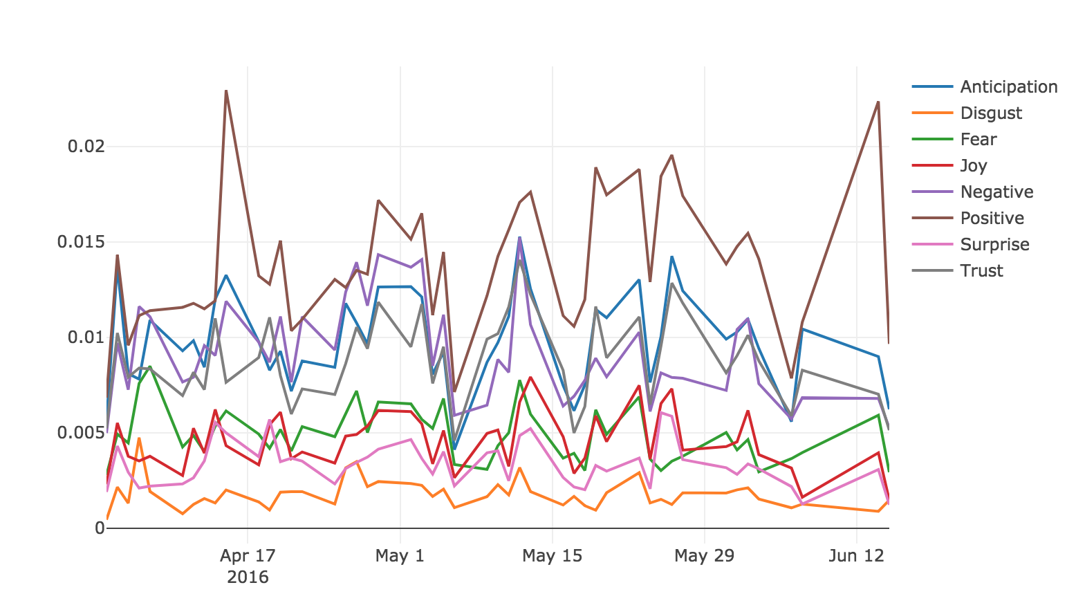

Pct_change over time for the 8 Emotions – Google

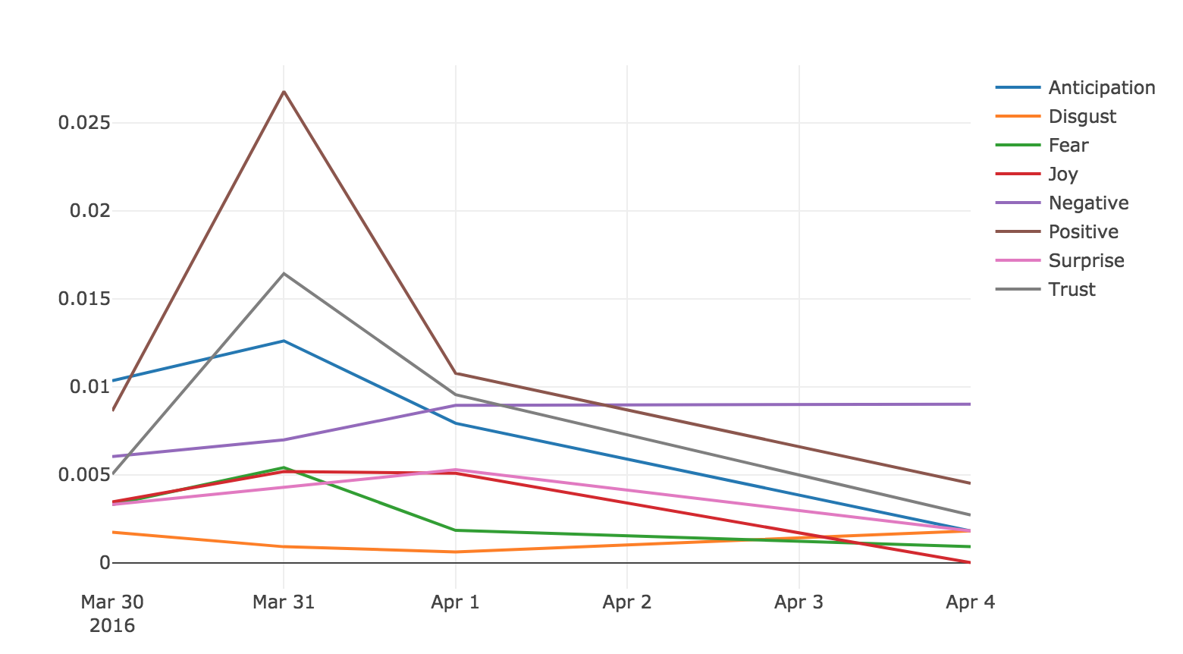

The 8 emotions follow almost the same trend in both plots. However, ‘positive’ sentiment is the largest all the time, while ‘Disgust’ is the lowest. The plots are consistent with the fact that Apple and Google are large technology companies and have good reputation. Compared to Apple, Google has more stable patterns except the large peak in March. It may because that Apple produced a lot of electronic devices and consumers tend to write various comments continuously.

Plot2: Pct_change over Time for Apple & Google

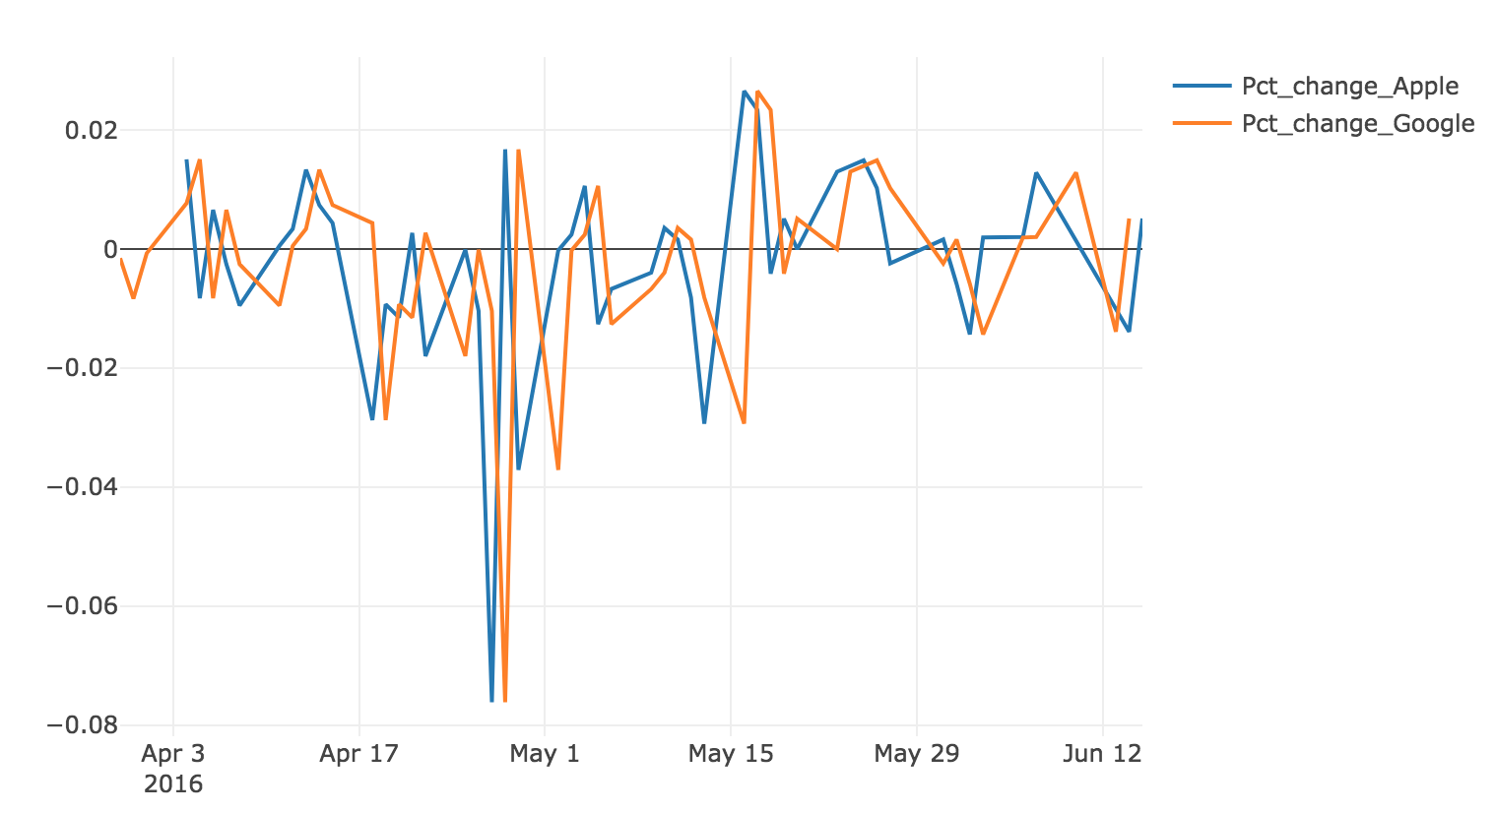

The Pct_change of the stock price of Apple and Google share almost the same pattern. It is consistent with the fact that they are from the same field and have similar size, and their stock prices are affected by same market factors.

Plot3: